LAB TASK – 3

# Program -1:

-🡪**Linear search**

#include<stdio.h>

int main ()

{

int a[50],n,target,i;

printf("enter the size of an array:");

scanf("%d",&n);

printf("enter the elements of array:");

for(i=0;i<n;i++)

{

scanf("%d",&a[i]);

}

printf("enter the element to search:");

scanf("%d",&target);

for (i=0;i<n;i++){

if (a[i]==target)

{

printf("successful element %d at a location %d\n",target,i+1);

break;

}

}

if(i==n)

printf("unsuccessful element %d in the array ",target);

return 0;

}

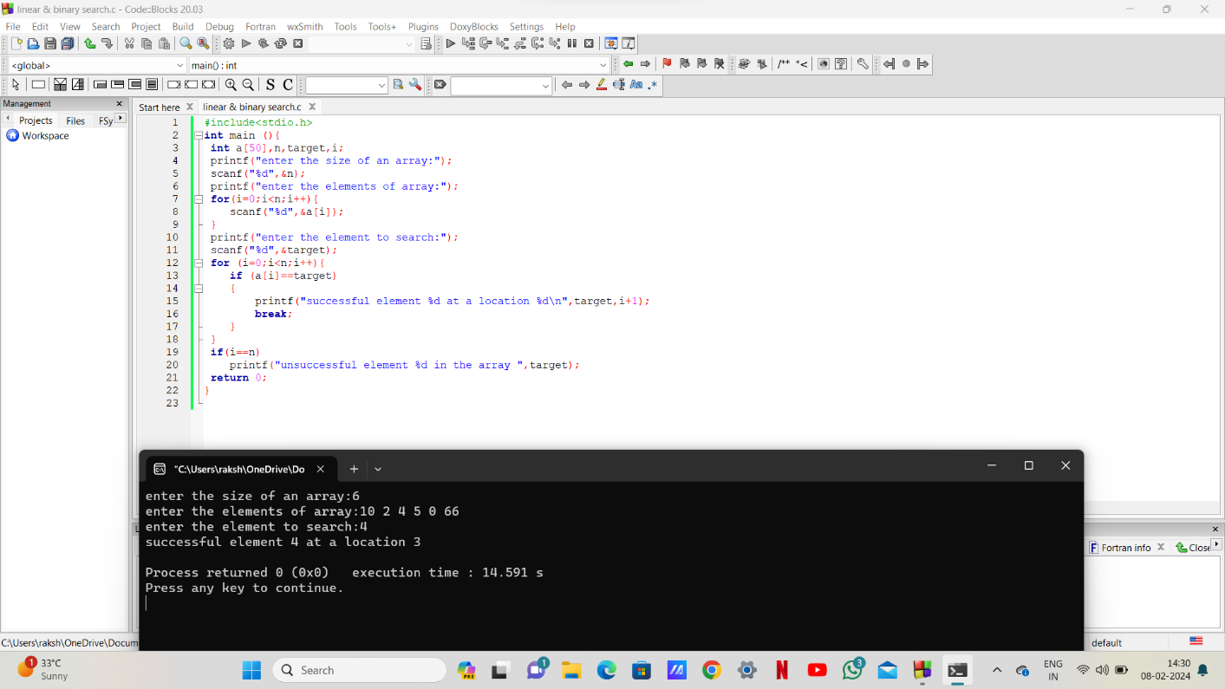

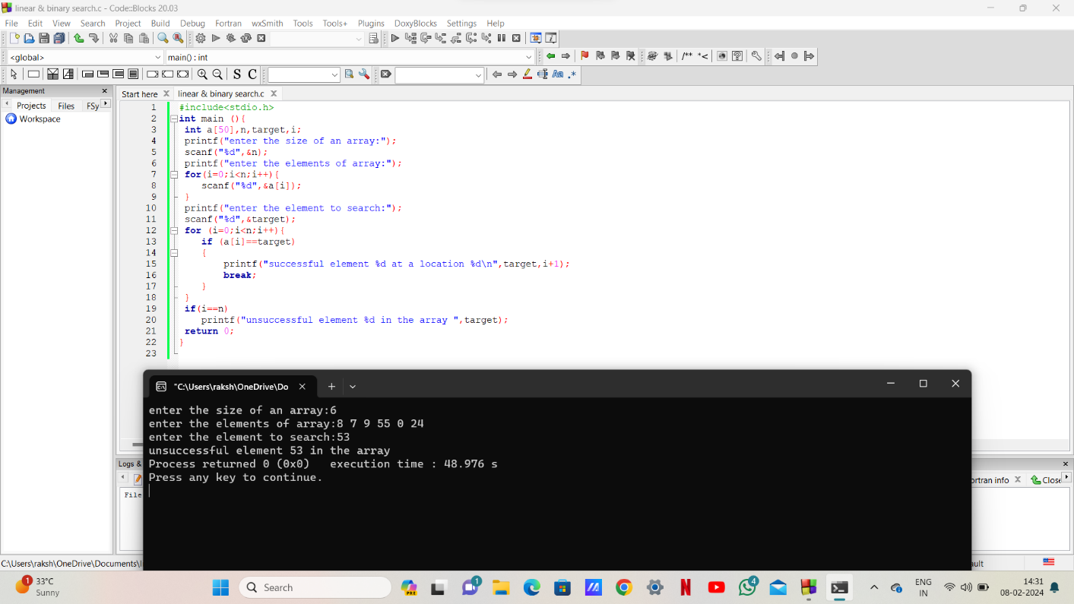

# Program – 2:

**🡪binary search**

#include<stdio.h>

int main ()

{

int a[50],n,i,target,first,last,mid;

printf("enter the size of an array:");

scanf("%d",&n);

printf("enter the elements of array:");

for(i=0;i<n;i++)

{

scanf("%d",&a[i]);

}

printf("enter the element to search:");

scanf("%d",&target);

first = 0;

last = n-1;

mid = (first+last)/2;

while(first<=last)

{

if(a[mid]<target)

{

first = mid+1;

mid=(first+last)/2;

}

else if(a[mid]==target)

{

printf("the number %d found at position %d",target,mid+1);

break;

}

Else

{

last = mid-1;

mid = (first+last)/2;}

}

if(first>last)

printf("the number %d not found in array ",target);

return 0;

}

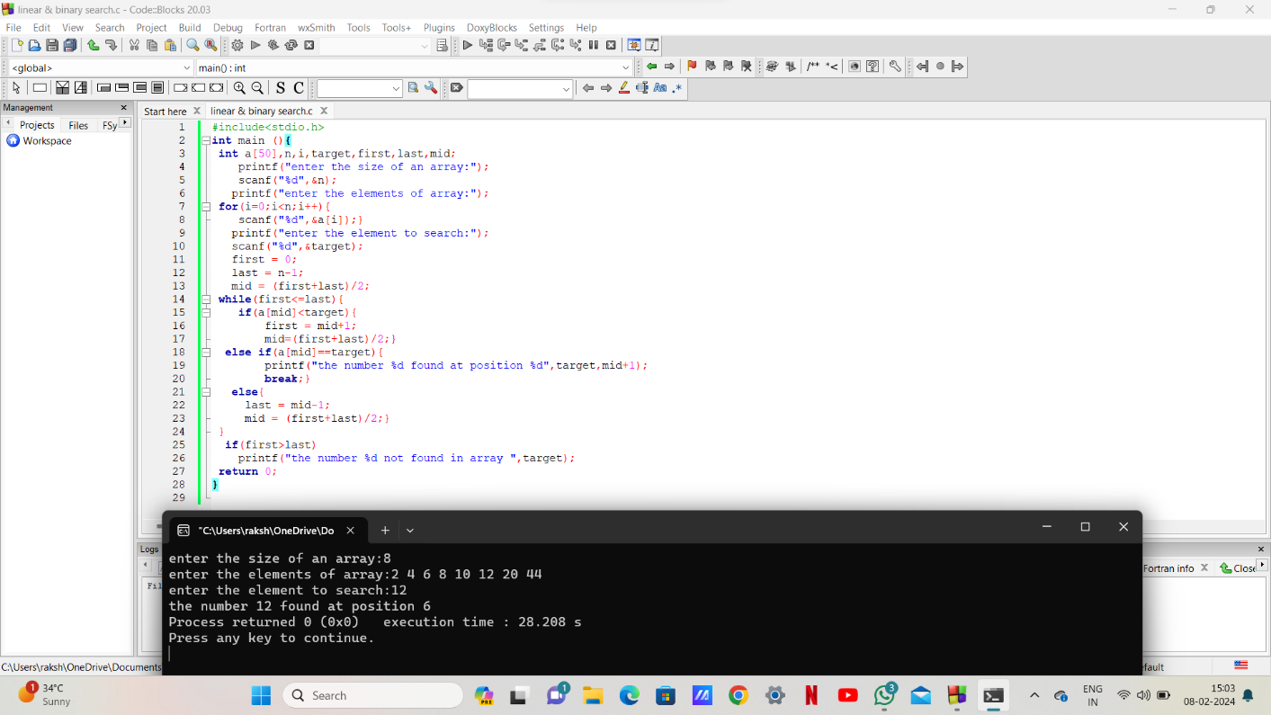

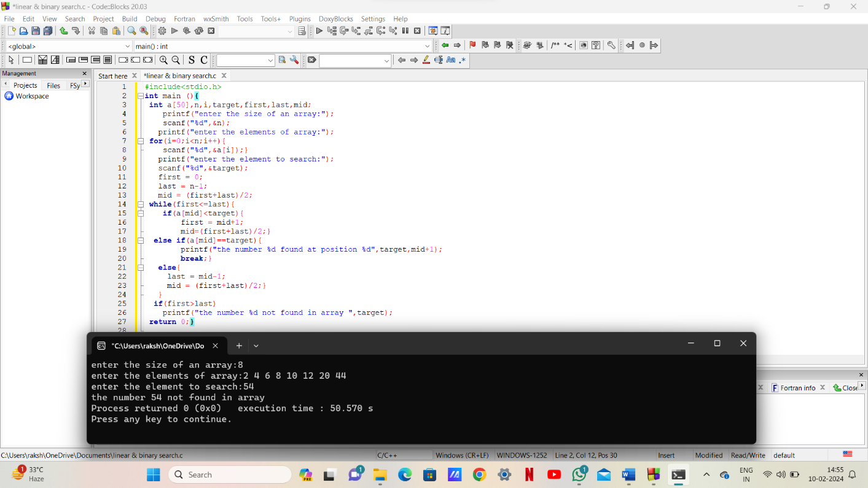

***THE END***